ASA College

Programming Languages Concepts

Term Project Paper

Lixin Shao Ph.D.

Gabriel Alejandro Molina Rodriguez

The project Temperature Converter has an excellent importance in a few subjects chemical, physic and biology. These are three subjects work with temperature measurement for calculations in experiments that the people do.

In chemical subject, people can use the Temperature Converter to get easy calculations in the states of matter gases, liquids and solids. Also when scientist are doing experiments and need to know which temperature put boil some liquid. In many countries transport international machines for their industries, and those international machines have one measurement that the countries doesn’t have, so with this GUI (Graphical User Interface) people can change the measurement easily.

At school when people are physic, a few topics are combined with temperature. For examples, in fluid statics students work with atmospheric pressure. This atmospheric pressure is related with some temperature, inasmuch as, the atmospheric temperature varies in some parts. Another examples is on the ideal gases, this theory works with the moving of particles. Ideal gases are studied with temperatures in degrees Kelvin and the interactions with elastic collisions, so if the people want to know the measurement in Celsius or Fahrenheit, they have to use the Temperature Converter.

Biology field has a many topics with temperatures, one of them is the meteorology. People speak about hot springs, volcanism and fermentations. Those nuclear reactions work with states matter, most of them are in degrees Celsius. Another example is the body temperature that is measured in Celsius, but in some countries is different. For those examples the Temperature Converter can be helpful to convert degrees Celsius to degrees Kelvin or Fahrenheit.

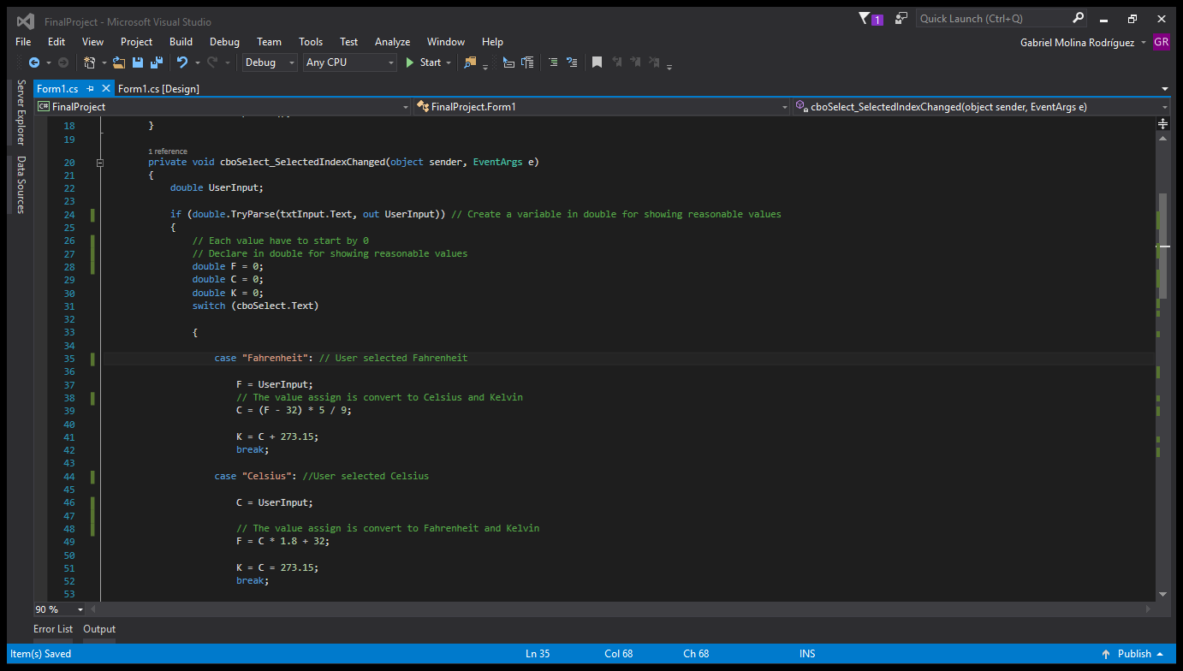

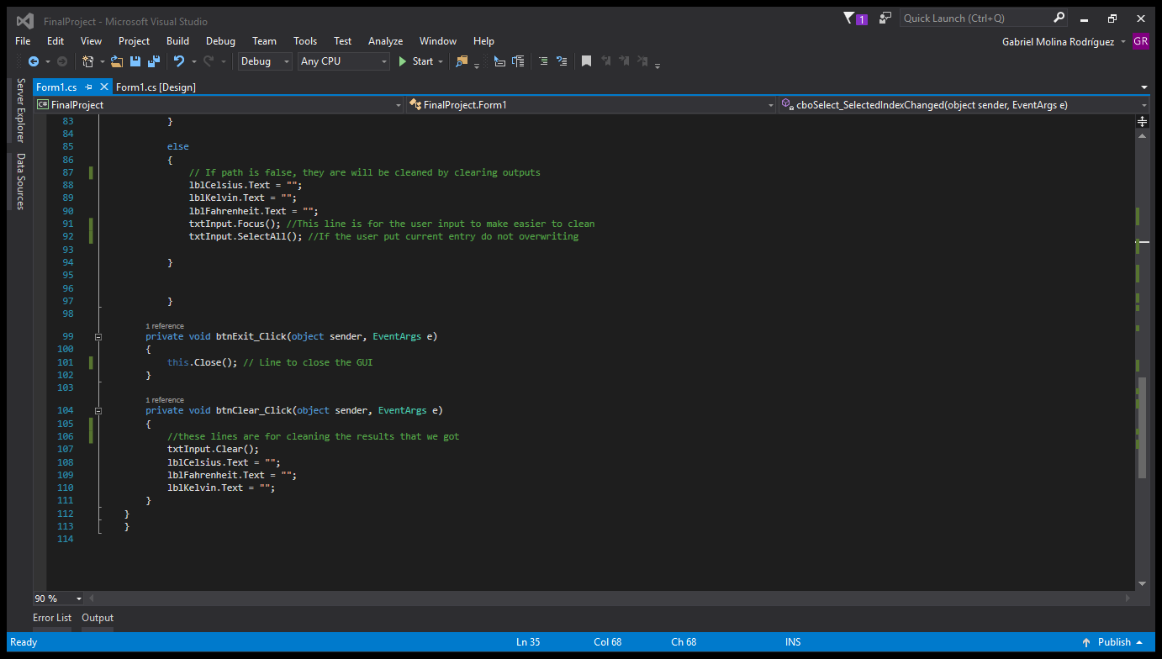

In sum, there are many options to improve this GUI (Graphical User Interface). One of them is showing combination with another subject like Physic or Biology, for example: use those values that people got and use it with mass or another measurement. Another improvement is adding information about the State of Matter, for example: where those values obtained can be liquid, solid or gas. And finally, enter a label to know how the calculations are done, sometimes the people want to know where you got the result. All these improvement are options to make better the GUI (Graphic User Interface).